

User Guide

December 2019



Real Life

Life Changing

Changing Healthcare

Copyright

NAVVIS Coreo View user's guide release 1.00.

Copyright © 2019 NAVVIS & Company, LLC. All rights reserved.

Trademarks

The other product names mentioned may be trademarks of their respective owners.

Disclaimer

Sample names and persons used in this document are purely fictitious and do not refer to real names or persons.

This user's guide has been created with utmost care; nevertheless, it is not guaranteed that this document is error free.

No part of this document may be reproduced or transmitted in any form or by any means, electronic or mechanical, for any purpose, without the express written approval of Navvis & Company.

Table of Contents

Preface 1

Exhibit A: Coreo View User Function 1

1 User On boarding 1

1.1 Okta single sign-on (SSO) 1

1.2 Log into Coreo View - First time user 1

1.3 Log into Coreo View - Existing users 1

2 Screen layout and navigation 1

2.1 The Bed View Layout 1

2.1.1 Header tool bar elements 1

2.1.2 Menu items 1

2.2 The Prioritized View Layout 1

2.3 The Geo-Map View Layout 1

3 Filters and themes 1

3.1 Screen layout 1

3.2 Filters 1

3.3 Themes 1

3.4 Normal view and Stacked view 1

3.5 All, Available and Patient views 1

4 Bed view features 1

4.1 Create bed 1

4.2 Assign patient 1

4.3 Move patients based on ADT (Admit Discharge Transfer) events 1

4.3.1 Request move 1

4.3.2 Quick move 1

4.3.3 Move within a location 1

4.3.4 Moving to another location 1

5 Prioritized view features 1

5.1 Card view 1

5.2 Sorting 1

5.3 Application of the date filters 1

5.4 Filters and themes 1

6 Geo-mapping view features 1

6.1 Geo-map view 1

6.2 Toggle views 1

6.3 Search functionality 1

6.4 Geo-map view plotting 1

6.5 Display settings 1

6.6 Drill down view 1

6.7 Pop up views 1

6.7.1 Acute Care 1

6.7.2 Post-Acute Care 1

6.7.3 Community resources 1

7 Switching the navigation between views 1

7.1 Toggle views 1

8 Patient summary 1

8.1 Layout and description of different tabs 1

8.2 View patient summary 1

8.3 Patient summary based on bed information 1

8.4 Patient summary based on length of stay (LOS) 1

8.5 Patient summary based on patient information 1

8.6 Length of stay (LOS) 1

8.7 Activities & attributes 1

8.8 Patient disposition 1

8.9 Bed attributes 1

8.10 Coreo face sheet 1

9 Search feature 1

9.1 Global search 1

9.1.1 Coreo summary 1

9.1.2 Flagged summary 1

9.1.3 Bed summary 1

9.1.4 Displayed search (Bed view search?) 1

10 Flagging patient records 1

10.1 Flag a patient record 1

10.1.1 Patient summary (Give reference to topic 8 above) 1

10.1.2 Global search 1

10.1.3 Prioritized view 1

10.1.4 Geo-map view 1

10.1.5 Bed view 1

10.2 Applying Filters and saving theme for flagged patients 1

10.3 Flagged Summary Pop Up Elaboration 1

11 General reports 1

Exhibit B: Coreo View Administrative Function 1

1 Coreo View Administrator Tasks 1

1.1 Navvis account activation for the Coreo View administrator user 1

1.2 Manage locked Navvis administrator account 1

1.3 Reset a forgotten or expired administrator password 1

2 Settings to manage Coreo View regular users 1

2.1 Settings page layout 1

2.2 Create groups 1

2.3 Manage user access 1

2.4 Set up locations 1

2.5 Manage patient cohorts 1

2.6 Manage user rosters 1

2.7 Create user roles 1

2.8 Create users 1

3 Automation Events 1

3.1 Discharging ED patients automatically and moving to CC after a configurable time 1

3.2 Moving the low risk patient automatically from ADT to cc after a configurable time 1

3.3 SIGNAL R –keeping the screen updated automatically 1

4 Administrative Reports 1

4.1 Automation reports 1

4.2 Automation action 1

5 Appendices 1

6 Glossary 1

7 Index 1

Preface

Welcome to the release of the NAVVIS Coreo View user’s guide.

About Navvis Coreo View

NAVVIS Coreo View is a software platform which empowers the users to manage the status and the flow of patients through Acute Care (AC), Post-Acute Care (PAC) and home networks.

Coreo View is HIPAA (Health Insurance Portability and Accountability Act) compliant and is available as a SaaS (Software-as-a-Service) cloud solution enabling management of patients with real-time data. Coreo View is part of the Coreo ecosystem which allows cross-continuum care coordination and ensures seamless care transition.

Navvis & Company provides counsel to health systems, hospitals and physician groups on the development of innovative, market-linked strategies to build future-ready health systems, cultivate tomorrow’s leaders and strengthen strategic performance.

Purpose of this document

This guide is the primary source of information about Navvis Coreo View. It contains overviews, processes, and procedure to use the Coreo View application effectively.

Intended audience

1. Coreo View administrator users who are assigned the task of managing the regular users of the Coreo View application
2. The regular users of the application who include the following personnel:

* Clinical staff and hospital administrators
* Employees, consultants, contractors or agents of the clinicians or patients who have been invited by the clinician or patient to access and use the service to participate in the care of the patient.
* Any other person or entity involved in the care of the patient including patient's care providers, patient's insurer or payer, or a social worker, or government agencies.

Organization of the document

This document contains the following modules:

* Exhibit A: Coreo View Administrative Function
  + Module 1, “Coreo View Administrator Tasks”
  + Module 2, “Settings to manage Coreo View regular users”
  + Module 3, “Automation events”
  + Module 4, “Administrative reports”
* Exhibit B: Coreo View User Function
  + Module 1, “User on boarding”
  + Module 2, “Screen layout and navigation”
  + Module 3, “Filters and Themes”
  + Module 4, “Bed view features”
  + Module 5, “Prioritized view features”
  + Module 6, “Goo-map view features”
  + Module 7, “Switching the navigation between views”
  + Module 8, “Patient summary”
  + Module 9, “Search feature”
  + Module 10, “Flagging patient records”
  + Module 11, “General reports”

Conventions

This document uses the following conventions:

| Convention | Item |
| --- | --- |
| **boldface** font | **Menu** items, **Tab** names, **Text** **box** names, **List** **box** names, **Button** names and **Navigation** paths |
| Text in blue | Hyperlinks |
|  | Note: Notes contain helpful suggestions. A note will inform the reader about any deviation in the sequence of instructions or helps the reader save time in understanding why something is not working. |
|  | Tip: The information will help the user solve a problem faster, or to perform an action in a different way. |
|  | Caution alerts the reader to avoid doing something that could result in loss of data or any other damage. |

Browsers versions for Coreo View

The Coreo View application is available on desktops, laptops, IOS devices and android tablets.

| Browser | Version |
| --- | --- |
| Google Chrome | 74 |
| MS Internet Explorer | 11 |
| Macbook - Safari | 12.1.1 |
| Samsung Tab – Google Chrome | 7.0.0 |
| IPad IOS - Safari | 12.1 |

Exhibit A: Coreo View User Function



# User On boarding

## Okta single sign-on (SSO)

A first-time user of Coreo View receives an automated email verification link from the Okta system administrator to activate the Okta account to use Coreo View. okta provides a single secure home page to use the Coreo View application.

## Log into Coreo View - First time user

Follow these steps to activate the Okta account and to access Coreo View:

1. Open the email link sent to your email inbox by the Okta administrator.



1. Email Notification
2. Select the ActivateAccLinkGreenBox.png link. The **Create your Navvis account** screen opens.

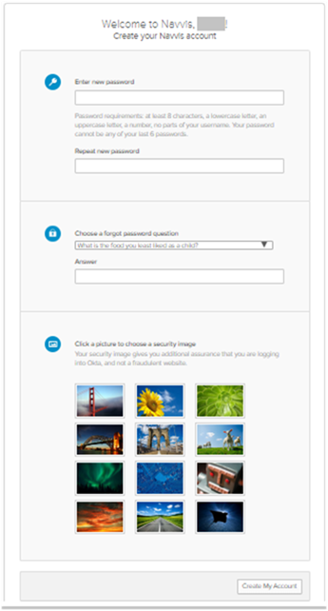

1. Create Your Navvis Account Screen
2. Enter the new password in **Enter new password**. The password must be at least 8 characters long and a maximum of 25 characters.

The password must be a combination of these following characters:

| Description | Characters |
| --- | --- |
| Upper case characters | A – Z |
| Lower case characters | a – z |
| Digits | 0 – 9 |
| Special characters | ~ ! @ # $ % ^ & * _ - + = ` | \ () {} [] : ; " ' < > , . ? / |

1. System Accepted Password Characters
2. Reenter the password in the **Repeat new password** box.
3. The user must add a security question to reset a new password in the event of the user forgetting the password during the future use.
4. Under **Choose a forgot password** question, select the arrow to view the questions.



1. Choose A Forgot Password Question
2. Choose a security question from the list.
3. In the **Answer** box, enter the answer. You must remember this answer because it is used at a later date to reset a forgotten or expired password.
4. Choose a picture as a security image in the **Create your Navvis account** screen and then select **Create My Account**.

|  |  |
| --- | --- |
| Note icon.png | The security image displays in the NAVVIS Sign In screen when the user logs in. |

1. The **Navvis** landing screen opens.

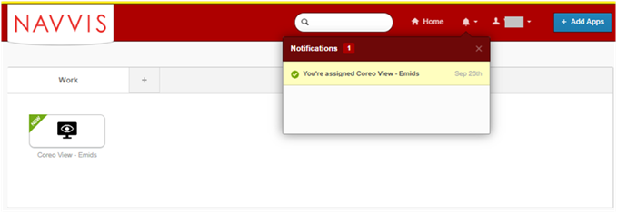

1. NAVVIS Landing Screen

## Log into Coreo View - Existing users

# Screen layout and navigation

Each screen in Coreo View has the same structure; however, few user interface elements differ depending on the user’s role and permissions.

Menu Items – Left Panel

| Description | Characters | Description |
| --- | --- | --- |
|  | Home menu item | Opens the home screen, the first screen of Coreo View |
|  | Move menu item | Use this to processes the patient move requests |
|  | Filter menu item | Use this to display views based on the filter criteria |
|  | Themes menu item | Use this to create and save new themes based on the filter criteria. |
|  | **Search** menu item | Use this to do a global search of patients from the Coreo application. |
|  | Reports menu item | Use this to generate facility reports, audit log reports and automation log reports. |
|  | Settings menu item | Use this to manage groups, locations, patient cohorts, user access and permissions. |
|  | Help menu item | Use this to access the Coreo View user help file. |
|  | Logout menu item | Use this to logout of the Coreo View application. |
|  | All Beds icon | Displays all the available beds |
|  | Normal view icon |  |
|  | Stack view icon |  |
|  | All icon |  |
|  | Available icon |  |
|  | Patients icon |  |

The Coreo View users can view the patient data in the following three layouts:

* The **bed view**
* The **prioritized** **view**
* The **geo**-**map** **view**

## The Bed View Layout

The bed view layout displays the patient information based on the type of care group, location, patient cohorts, patient attributes, bed attributes, bed activities, and patient move requests. The bed view is the home default layout.

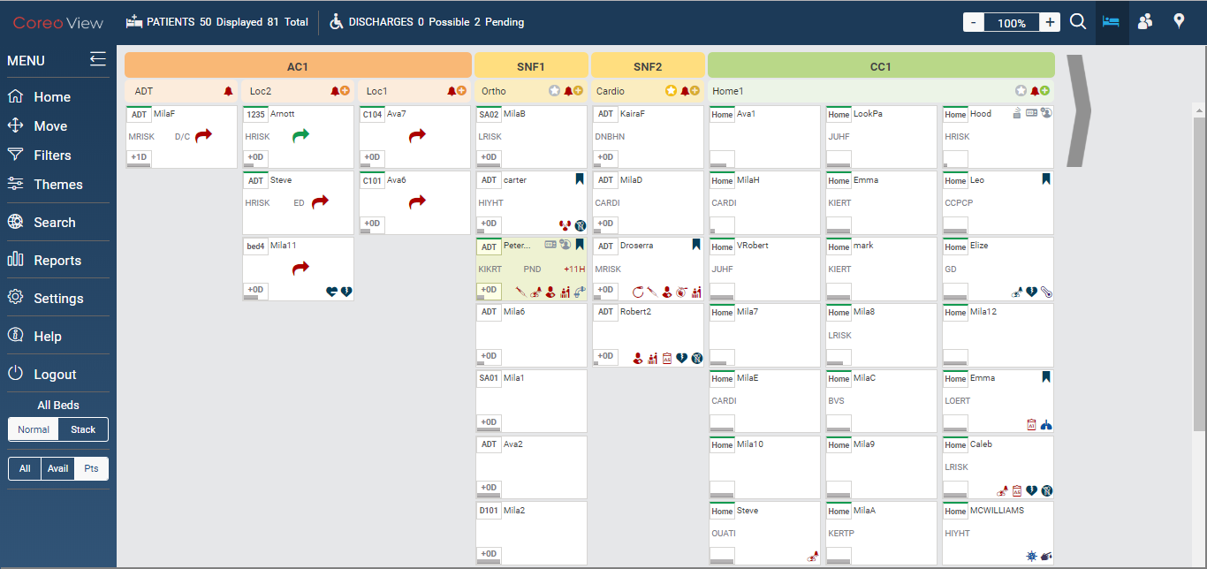

1. The Bed Layout View

Header tool bar elements

Refer to the below table for details about the header tool bar elements of the bed view layout:

|  |  |  |
| --- | --- | --- |
| Icon | Icon Name | Description |
|  | Coreo View | The Coreo View icon |
|  | PATIENTS | Patient details icon |
|  | Displayed | The number of patients across all the three groups, Acute Care (AC), Post-Acute Care (PAC), and Cross Continuum (CC) displayed in the bed view |
|  | Total | The total number of patient across all the three groups. |
|  | DISCHARGES | Patient discharge |
|  | Possible | The number of possible patient-discharges |
|  | Pending | The number of pending patient-discharges |
|  | Magnification icon | Zoom in (+) to increase or zoom out (-) to decrease the bed view layout magnification. 60% being the least and 240% being the maximum magnification values. |
|  | Global search | Search the records in bed view based on criteria such as patient name, MPI, group, location, cohort details. |
|  | Bed view | Displays the patient information based on the different care facilities assigned to them such as hospitals, skilled nursing services and home care services |
|  | Prioritized view |  |
|  | Geo-map view |  |

1. Header Tool Bar Elements

Bed View Layout Elements

Refer to the table below for details about the bed view layout elements:

|  |  |  |
| --- | --- | --- |
| Icon | Element name | Description |
|  | Group header bar | The header bar displaying the group color code and the group name |
|  | AC group bar | The color code for Acute Care (AC) group |
|  | PAC group bar | The color code for Post-Acute Care group |
|  | CC group | Color code for Cross Continuum group |
|  | Location header bar | The header bar displaying the location attached to the group |
|  | Location name | The location belonging to the group |
|  | Star icon |  |
|  | Bell icon (Red) | Indicates overdue patient activities, patient move request, pending patient discharges and bed cleaning tasks. |
|  | Create bed icon | Create a new bed. |
|  | Bed cells | A bed cell displays the pictorial summary of a bed, any assigned patient and all the related information. The summary is displayed as component icons. |
| Bed cell component icons | Icon name | Description |
|  | Bed id | The bed identification number |
|  | Patient name | The first name of the patient |
|  | Bed attributes | The bed attributes include Male Room, Female Room and so on. Refer to the Bed Attributes figure to view the complete list of bed attributes. |
|  | Flag |  |
|  | Alert time frame | An alert displays if the patient disposition is not carried out within the set time frame. |
|  | Move request arrow. | The green arrow indicates that the patient’s move request from a bed to another bed is accepted. The red arrow indicates the rejected request. |
|  | Patient disposition | The patient disposition status which includes the following:   * The Emergency * Observation * Admitted * Discharge possible * Discharge pending * Discharge complete |
|  | Patient cohort | The cohort the patient is assigned to.  The patients are categorized into cohorts based on their ailments and the risk factor associated with it. |
|  | LOS indicator | The patient’s length of stay in the facility in days. |
|  | Patient attributes | The patient attributes include **Chest Pain**, **Fall** **Risk**, **Diabetes** and so on. Refer to the Patient Attributes figure to view the complete list of patient attributes. |

## The Prioritized View Layout

Use the **Prioritized view** feature to display the patient details and bed information of the AC group based on the following options:

* **Most Inpatient Admissions**
* **Most Emergency Visits**
* **Highest Risk Scores**
* **Most Recently Admitted - Inpatient**
* **Longest Length of Stay**

The screen layout for each of the prioritized layout view is almost the same except for few items which is detailed in the following sections.

Screen Layout for Most Inpatient Admissions

Refer to the figure for the prioritized view layout with most patient admissions:

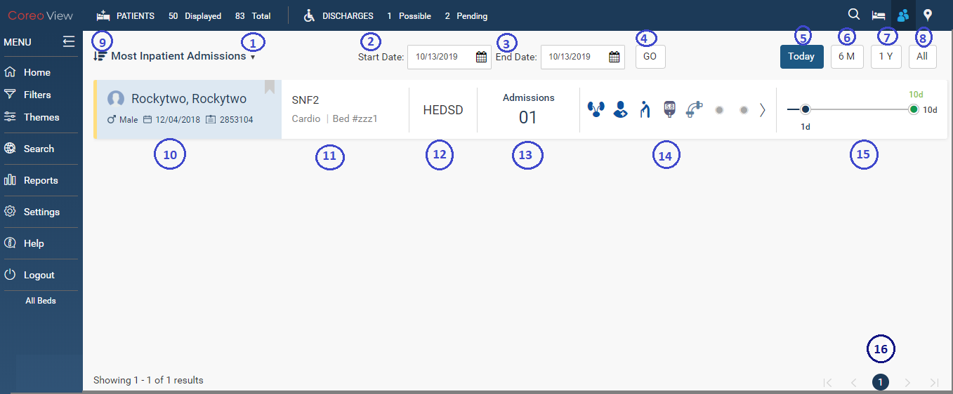

1. Prioritized View – Most Inpatient Admissions

Refer to the following table for the user interface element details:

|  |  |  |
| --- | --- | --- |
| Serial Number | Element name | Description |
| **1** | Prioritized view drop-down menu | Use the drop-down menu to select the prioritized view criteria to display the information. |
| **2** | **Start Date** box | Select the start date of the period for which the prioritized view details must be displayed. |
| **3** | **End Date** box | Select the end date of the period for which the prioritized view details must be displayed. |
| **4** | **Go** button | Select the **Go** button to display the prioritized view details for the selected period. |
| **5** | **Today** button | Select the **Today** button to view the most inpatient admissions for the current date. |
| **6** | **6M** button | Select the **6M** button to view the most inpatient admissions for the previous six months from the current date. |
| **7** | **1Y** button | Select the **1Y** button to view the most inpatient admissions for the previous one year from the current date. |
| **8** | **All** button | Select the **All** button to view all the inpatient admission records. |
| **9** | **Sort** icon | Doesn’t sort |
| **10** | Patient name | Displays the patient full name, gender, and the MPI |
| **11** | Group name | Displays the AC group name, location, and the identification number of the bed the patient is assigned to |
| **12** | Patient cohort | Indicates the high risk, medium risk, or low risk cohort for the patient. |
| **13** | **Admissions** | Displays the total number of admissions of the patient |
| **14** | Bed attributes, Patient attributes and activities | Displays the bed attributes, patient attributes and patient activities |
| **15** | Length of stay indicator | The patient’s length of stay in the facility expressed in number of days. |
| 16 | Pagination | The total number of pages the prioritized view details are displayed in. |

Screen Layout for Most Emergency Visits

|  |  |  |
| --- | --- | --- |
| Serial Number | Element name | Description |
|  |  |  |
|  |  |  |
|  |  |  |
|  |  |  |

Screen Layout for Highest Risk Scores

Refer to the figure for the prioritized view layout of the patients with highest risk scores:

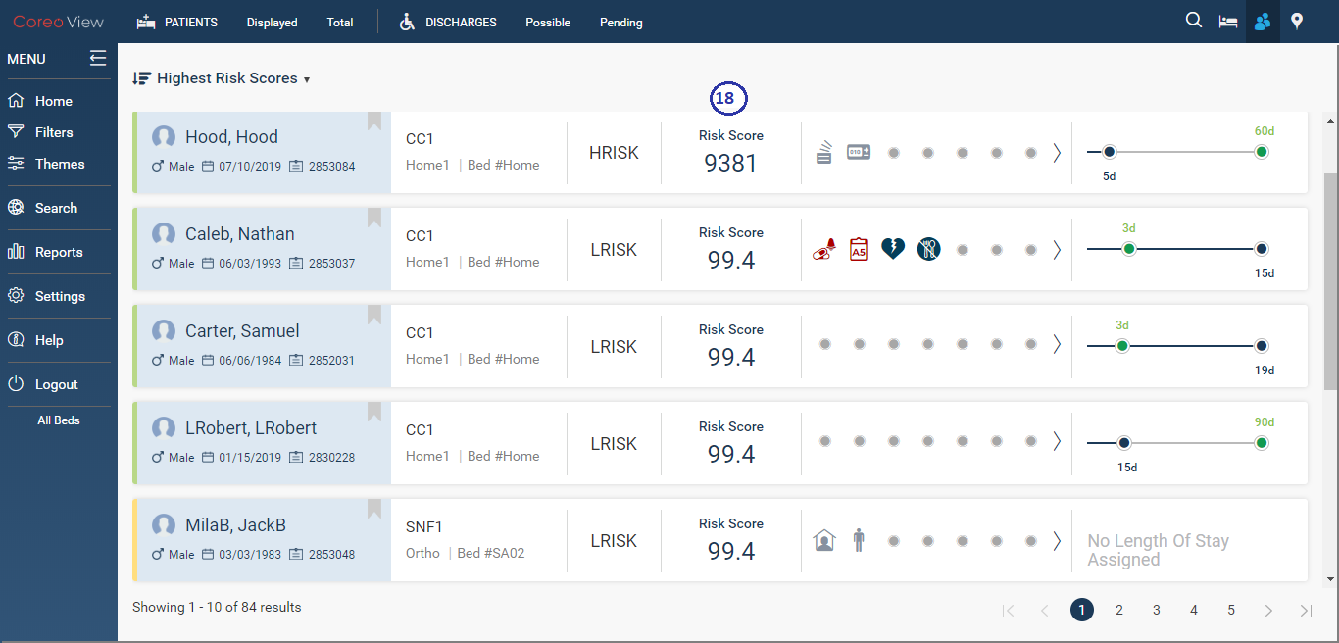

1. Prioritized View – Highest Risk Scores

Refer to the following table for the user interface element details:

|  |  |  |
| --- | --- | --- |
| Serial Number | Element name | Description |
| 18 | **Risk score** indicator | The high risk, medium risk, or low risk score of the patient matching the cohort. |

Screen Layout for Most Recently Admitted – Inpatient

Refer to the figure for the prioritized view layout of the most recently admitted inpatients:

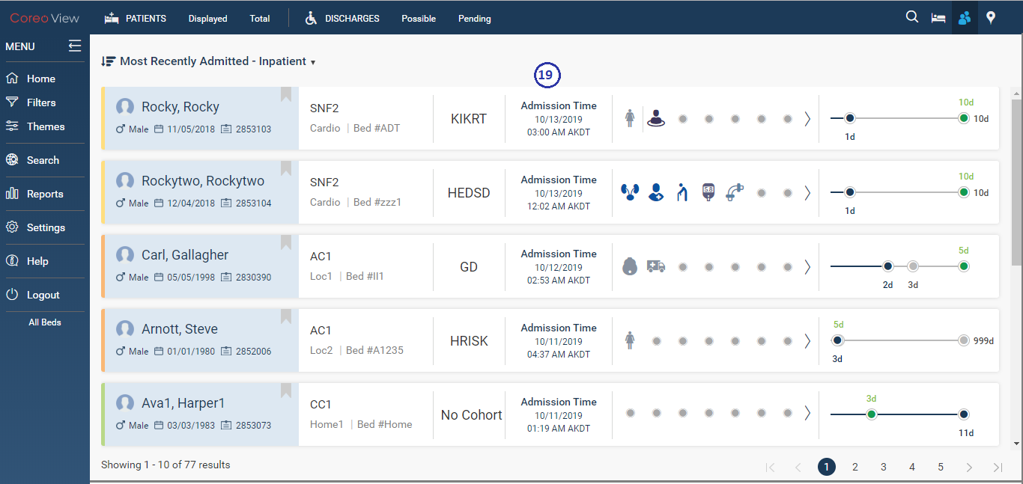

1. Prioritized View – Most Recently Admitted - Inpatient

Refer to the following table for the user interface element details:

|  |  |  |
| --- | --- | --- |
| Serial Number | Element name | Description |
| 19 | **Admission Time** | The time at which the patient was admitted to the facility. |

Screen Layout for Most Recently Discharged – Inpatient

Refer to the figure for the prioritized view layout of the most recently discharged inpatients:

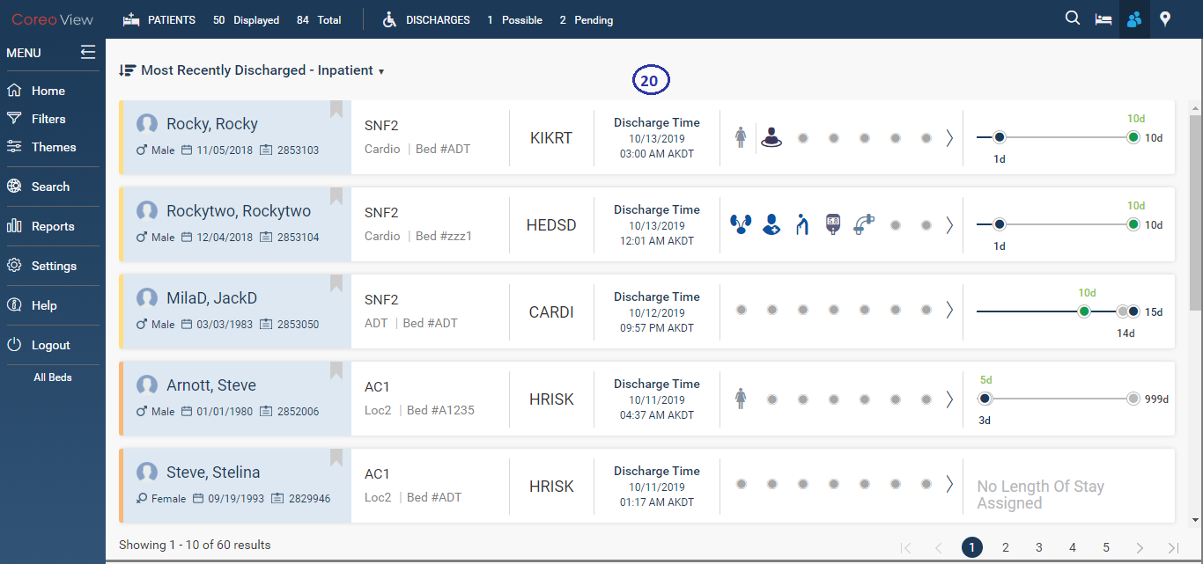

1. Prioritized View – Most Recently Dischaged - Inpatient

Refer to the following table for the user interface element details:

|  |  |  |
| --- | --- | --- |
| Serial Number | Element name | Description |
| 20 | **Discharge Time** | The time at which the patient was discharged from the facility. |

Screen Layout for Longest Length of Stay

Refer to the figure for the prioritized view layout of the longest length of stay of the patients:

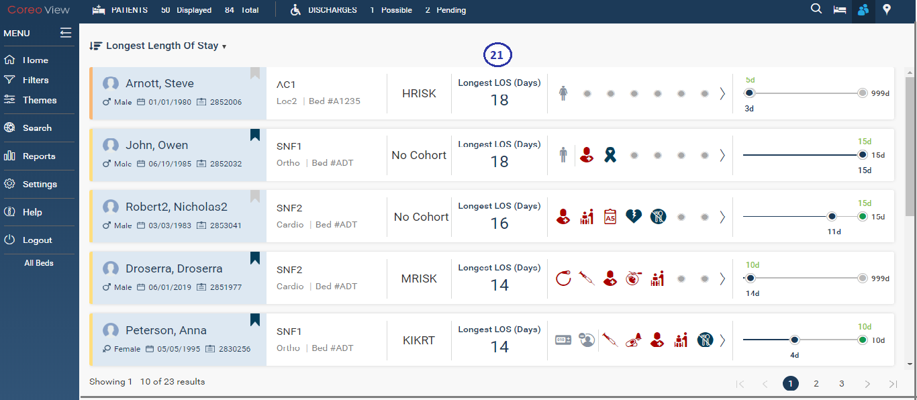

1. Prioritized View – Longest Length of Stay

Refer to the following table for the user interface element details:

|  |  |  |
| --- | --- | --- |
| Serial Number | Element name | Description |
| 21 | Longest LOS (Days) | The standard length of stay of the patient in days for that level of care, the different levels of care being AC, PAC, and CC. |

## The Geo-Map View Layout

Use the **geo-map view** feature to display the patient details and bed information based on the following options:

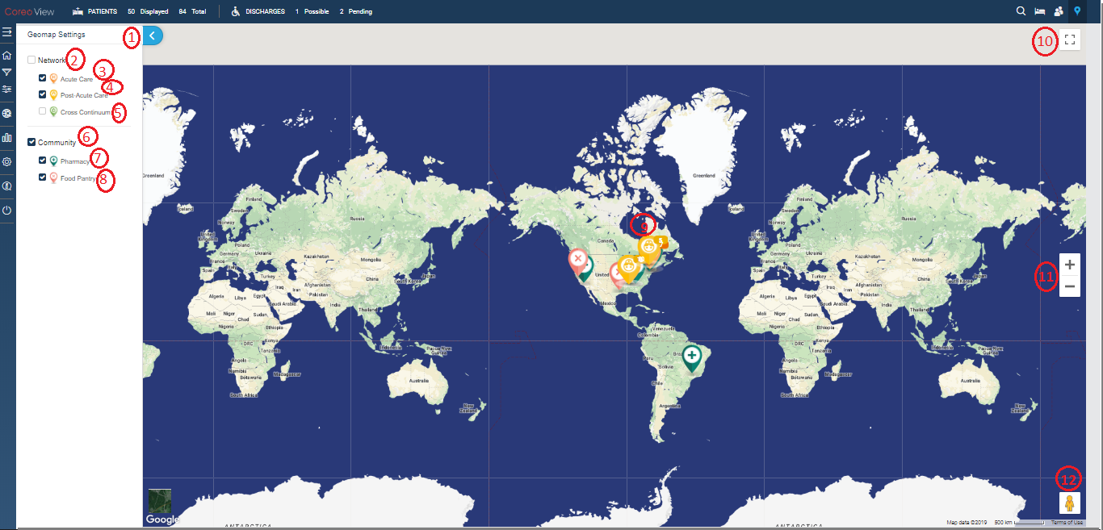

1. Geomap View Layout

|  |  |  |
| --- | --- | --- |
| Serial Number | Element name | Description |
| 1 | **Geomap Settings** arrow | Select the arrow to expand the Geomap settings menu. |
| 2 | **Network** check box | Select the **Network** check box to view the geographical location of all the three groups. |
| 3 | **Acute Care** check box | Select the **Acute Care** check box to view the geographical location of the AC group. |
| 4 | **Post-Acute Care** check box | Select the **Post-Acute** **Care** check box to view the geographical location of the PAC network. |
| 5 | **Cross Continuum** check box | Select the **Post-Acute** **Care** check box to view the geographical location of the CC network. |
| 6 | **Community** check box | Select the **Community** check box to select the **Pharmacy** check box and the **Food** **pantry** check box. |
| 7 | **Pharmacy** check box | Select the **Pharmacy** check box to view the nearest pharmacy locations in the neighborhood. |
| 8 | **Food Pantry** check box | Select the **Pharmacy** check box to view the nearest food pantry locations in the neighborhood. |
| 9 | Group Indicator/Legend | Shows the geographical location of the three groups, amber for AC, yellow for PAC and green on CC |
| 10 | Toggle Full Screen icon | Use this button to view the geomap layout in full screen mode. Toggle this button to change to the window screen mode. |
| 11 | Magnification icon | Zoom in (+) to increase or zoom out (-) to decrease the geomap view layout magnification. |
| 12 | Peg man icon | Drag the peg man to the desired location in the geomap to zoom into the street view imagery. |



# Using Filters and Themes

The Coreo View users can apply the filter criteria to the patient details, bed details and all associated information to display only the related records and clear other records from the view.

A theme customizes the look of the screen and its layout. Coreo View allows its users to create and save new themes based on the filter criteria.

## Filters

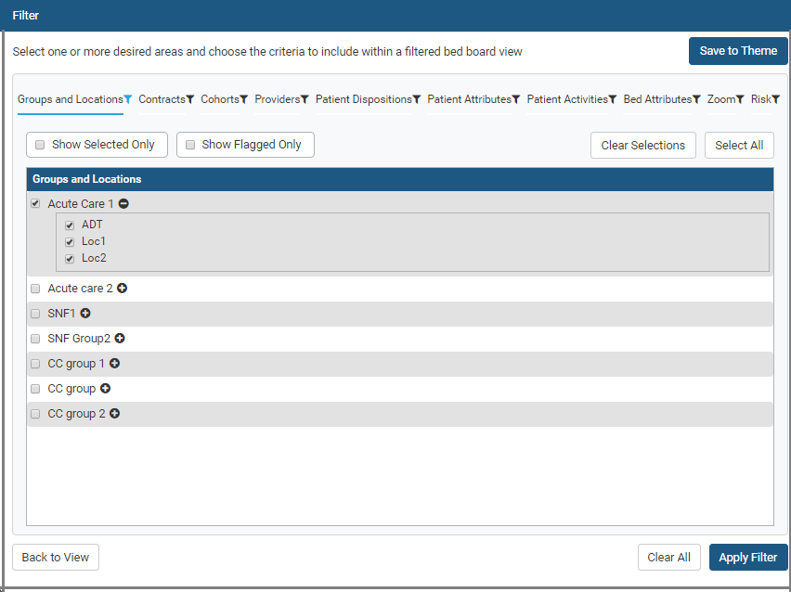

1. Filter Screen

Filter feature in Coreo View helps

You can filter the patient records based on the following criteria:

* **Groups and Locations**
* **Contracts**
* **Cohorts**
* **Providers**
* **Patient Dispositions**
* **Patient Attributes**
* **Patient Activities**
* **Bed Attributes**
* **Zoom**
* **Risk**

## Themes

## Normal view and Stacked view

## All, Available and Patient views

# Bed view features

## Create bed

## Assign patient

## Move patients based on ADT events

Request move

Quick move

Move within a location

Moving across locations

# Prioritized view features

## Card view

## Sorting

## Application of the date filters

## Filters and themes

# Geo-mapping view features

## Geo-map view

## Toggle views

## Search functionality

## Geo-map view plotting

## Display settings

## Drill down view

## Pop up views

Acute Care

Post-Acute Care

Community resources

# Switching navigation between views

## Toggle views

# Patient summary

Layout and description of different tabs

View patient summary

Patient summary based on bed information

Patient summary based on length of stay (LOS)

Patient summary based on patient information

Length of stay (LOS)

Activities & attributes

Patient disposition

Bed attributes

Coreo face sheet

# Search feature

Global search

Coreo summary

Flagged summary

Bed summary

Displayed search (Bed view search?)

Flagging patient records

Flag a patient record

Patient summary (Give reference to topic 8 above)

Global search

Prioritized view

Geo-map view

Bed view

Applying Filters and saving theme for flagged patients

Flagged Summary Pop Up Elaboration

General reports

Exhibit B: Coreo View Administrative Function



# Coreo View Administrator Tasks

The okta Single Sign-On system administrator has the super user privileges and creates the Coreo View administrator role. okta provides a single secure home page to use the Coreo View application.

The Coreo View administrator manages the users and all the related administrative functions, which include the following:

* Manages the regular users of the Coreo View application.
* Assigns roles and permissions for the regular users from the user groups.

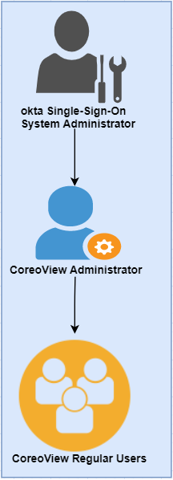

1. Administrator Role Hirearchy

## Navvis account activation for the Coreo View administrator user

The okta system administrator will register a user in okta and assigns the administrative privilege and access to the Coreo View application. The Coreo View administrator user manages the Coreo View regular users.

The okta system administrator sends an email notification to the Coreo View administrator user to initiate the account activation process.

|  |  |
| --- | --- |
| Note icon.png | okta sytem administrator can create multiple Navvis administrator accounts for the Coreo View application. However, the Coreo View administrator can only assign the administrator role to another user in Coreo view. |

Follow these steps to activate the Okta account:

1. Open the email link sent to your email inbox by the Okta administrator.



1. Email Notification

2. Select the ActivateAccLinkGreenBox.png link. The **Create your Navvis account** screen opens.

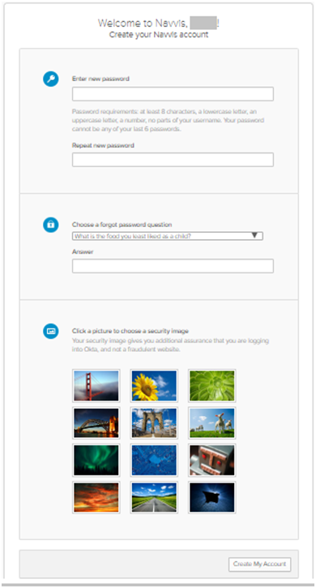

1. Create Your Navvis Account Screen
2. Enter the new password in **Enter new password**. The password must be at least 8 characters long and a maximum of 25 characters.

The password must be a combination of these following characters:

| Description | Characters |
| --- | --- |
| Upper case characters | A – Z |
| Lower case characters | a – z |
| Digits | 0 – 9 |
| Special characters | ~ ! @ # $ % ^ & * _ - + = ` | \ () {} [] : ; " ' < > , . ? / |

1. System Accepted Password Characters
2. Reenter the password in the **Repeat new password** box.

The user must add a security question to reset a new password in the event of the user forgetting the password during the future use.

1. Under **Choose a forgot password** question, select the arrow to view the questions.

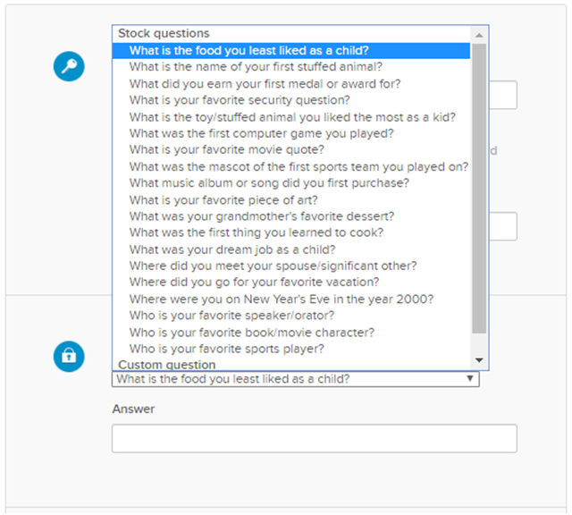

1. Choose A Forgot Password Question
2. Choose a security question from the list.
3. In the **Answer** box, enter the answer. You must remember this answer because it is used at a later date to reset a forgotten or expired password.
4. Choose a picture as a security image in the **Create your Navvis account** screen and then select **Create My Account**.

|  |  |
| --- | --- |
| Note icon.png | The security image displays in the NAVVIS Sign In screen when the user logs in. |

1. The **Navvis** landing screen opens.

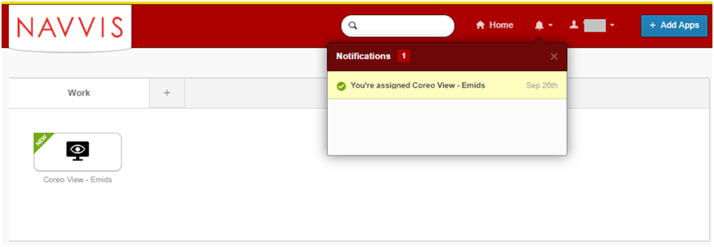

1. NAVVIS Landing Screen
2. Select the **Coreo View - Emids** icon on the landing screen.
3. The **NAVVIS Sign in** screen opens.

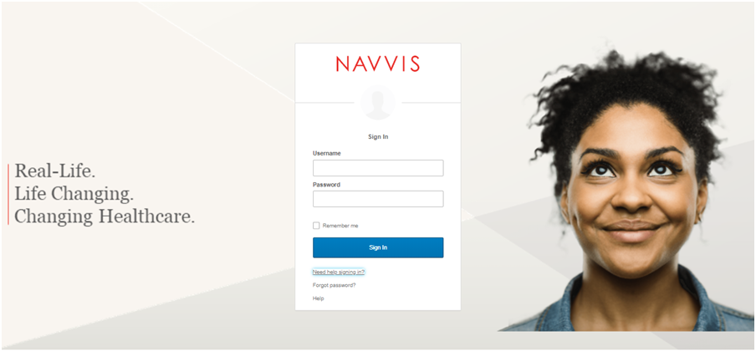

1. NAVVIS Sign In Screen
2. Enter the user ID in the **Username** box on the.
3. Enter the password in the **Password** box. The password must be at least 8 characters long and a maximum of 25 characters.
4. Select **Sign In**.
5. The EULA screen displays for a first-time user of Coreo View. A first-time user of Coreo View is required to accept the EULA (End User License and Business Associate Agreement) before accessing the Coreo View application.

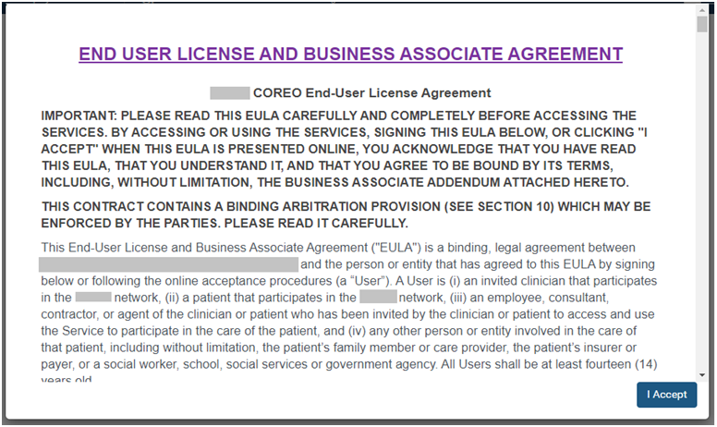

1. EULA PAGE
2. Read the terms and conditions and select the **I Accept** button. Your Navvis account is activated successfully and the NAVVIS home page opens.

## Manage locked Navvis administrator account

The Navvis account locks for the following reasons:

* The user exceeds five failed login attempts within 24 hours. The login attempts fail when the user enters an incorrect password.

To unlock the Navvis account immediately after the five failed login attempts, contact the okta system administrator.

|  |  |
| --- | --- |
| Note icon.png | The locked account resets after 24 hours and the user can log in to the account after 24 hours. |

* The okta system administrator can lock the Navvis account as per the company lock account policy.

## Reset a forgotten or expired administrator password

The okta Single Sign-On password policy specifies that the password expires after 60 days, and the user must reset the password periodically.

Also, if the user forgets the password, Coreo View gives the option to reset the password.

Follow these steps to reset the password:

1. Go to www.navvis.oktapreview.com to open the **Navvis Sign in** screen.

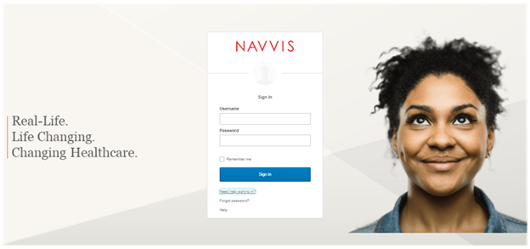

1. NAVVIS Sign In Screen - Forgot password? Option
2. Select the **Need help signing in?** drop-down list.
3. Select the **Forgot password?** option to open the **Reset Password** screen.

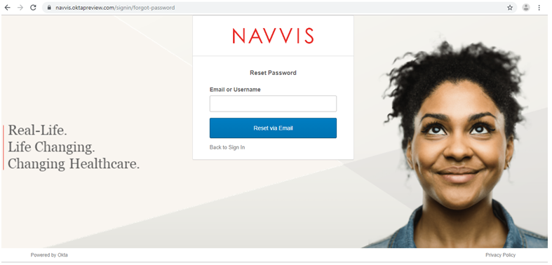

1. Reset Password Screen
2. Enter the e-mail or the user name in the **Email or Username** box.
3. Select **Reset via E-mail**. The user can reset the password using the verification link sent to the user’s email address.
4. Reset the password with the following considerations:

* The new password cannot be among the previous six passwords.
* The password expires after 60 days and the user must reset the password periodically.
* The user will be locked out of the application after five failed login attempts. The login attempts fail when the user enters an incorrect password. Contact the okta administrator to reset the password.

On the successful resetting of the password, the new password is reset for the Navvis account.

Settings to manage Coreo View regular users

The user management settings for Coreo View is set up by creating hospital groups, locations, users, user roles, user permissions to use the features, user roasters and patient cohorts.

## Settings page layout

Each screen in Coreo View has the same structure; however, few user interface elements differ depending on the user’s role and permissions.

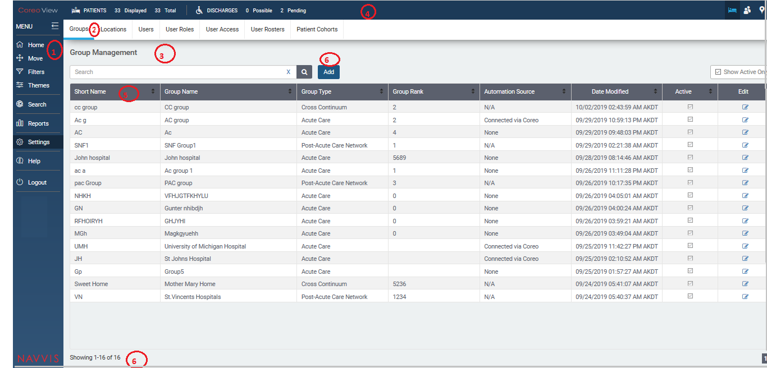

1. Settings Page Layout

## Create groups

The Coreo View application provides the following three groups to categorize patients based on the care facilities that they are provided with.

a) Acute care: Acute care group includes emergency department, intensive care, coronary care, cardiology, neonatal intensive care and so on.

b) Post-Acute Care (PAC) network: Under this care group, patients are cared with skilled nursing facilities, inpatient rehabilitation facilities, long-term acute hospital facilities among others.

c) Cross continuum: Under this care group, patients are cared at their home locations and are served by home-health and outpatient services.

Follow these steps to create a new group in the Coreo View application:

1. Click the Settings menu in the left pane on the Coreo View home page.

2. Click the Add button under the Groups tab. The Add Group tab page opens.

3. Select the type of group from the following options:

• Acute Care

• Post-Acute Care Network

• Cross Continuum

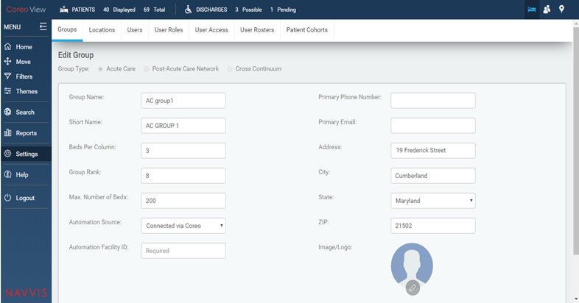

FIGURE 1. GROUPS TAB PAGE

For the Acute Care group type, enter the following details:

4. Enter the acute care group name in the Group Name: field.

5. Enter a short name for the acute care group in the Short Name: field.

6. View the number of beds allotted for each column for this group in the Beds Per Column: field. You can modify this value.

7. View the group rank in the Group Rank: field. The user can modify this value.

8. View the maximum number of beds that is available for this care group in the Max. Number of Beds: field.

9. Select the automation source in the Automation Source: field from the following options:

• Connected via Coreo

• None

10. Enter the primary phone number of the care group in the Primary Phone Number: field.

11. Enter the primary email address of the care group in the Primary Email: field.

12. Enter the address details of the care group in the Address: field.

13. Enter the name of the city in which the care group is located in the City: field.

14. Select the State: arrow to view the states in the U.S region and then select the name of the state in the State: field.

15. Enter the ZIP code of the region that the care group belongs to in the ZIP: field.

16. Select the Save button to changes.

Manage user access

Follow these steps to create user roles on the User Access Management page.

1. On the Coreo View homepage, go to the Settings menu in the left pane.

2. Go to the User Roles tab to open the User Role Management page.

3. Select the Add button to add new user access on the Add User Access page.

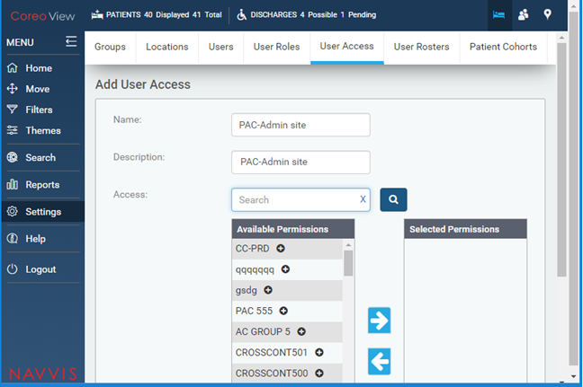

FIGURE 3. ADD USERS ACCESS TAB PAGE

4. Enter the user access name in the Name field.

5. Enter a description for the user access in the Description: field.

6. Enter the group in the Access: search box to grant the permission for and then click the Search button. The groups under the available permissions are displayed based on the search key word.

7. Select the appropriate group under Available permissions to give permissions to the user.

8. Select the right arrow button to move the selected group under Selected Permissions.

9. Click Save to save the user access permissions.

10. View the user access details on the User Access Management page.

## Set up locations

## Manage patient cohorts

## Manage user rosters

## Create user roles

The Coreo View application provides its users with role based permissions to its features.

The roles could include the following:

• Administrator super user

• Administrator

• Hospital administrator

• Hospital nurses / Care giver roles

• Hospital non-clinical roles

• Hospital role types - Care giver roles and Non-clinical roles

• PAC (Post-Acute Care) role types – PAC site admin, Care giver roles and Non-clinical/EVF roles

• CC (Cross Continuum) – CC site admin, Care giver roles and Non-clinical/EVF roles

Follow these steps to create user roles on the User Role Management page.

1. On the Coreo View homepage, go to the Settings menu in the left pane.

2. Go to the User Roles tab to open the User Role Management page.

3. Select the Add button.

4. Enter the name of the user role in the Name: field.

5. Enter a description for the user role in the Description: field.

6. Enter the feature in the Access Rights: search box to grant the permission for and click the Search button. The features under the available permissions are displayed based on the search key word.

7. Select the appropriate features under Available permissions to give permissions to the user role.

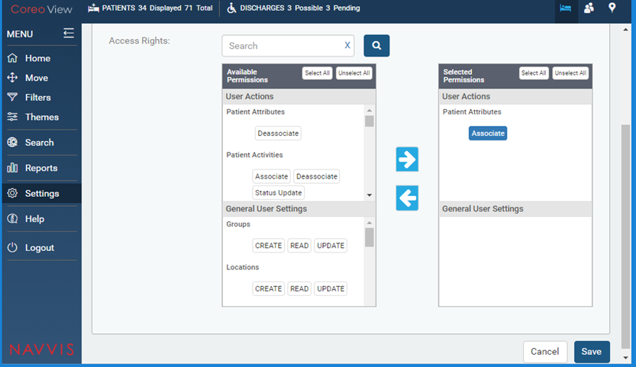

FIGURE 2. AVAILABLE PERMISSIONS FOR USER ROLES

8. Select the Select All button and then click the right arrow button to move the permissions under Selected Permissions.

The available permission for the user role is detailed in the tabular column below:

User Actions

Features Permissions

Patient Attributes Associate, Deassociate

Patient Activities Associate, Deassociate, Status Update

Bed Attributes Associate, Deassociate

Bed Cleaning Cleaning Required, Cleaning Complete

Move/Assign Patient Request Move, Assign Patient, Accept Move, Reject Move, Cancel Move, Quick Move

Providers & LOS Length of Stay

Patient Disposition Observation, Admitted, Discharge Possible, Discharge Pending, Discharge Complete, Emergency

Patients READ, UPDATE, DELETE

Audit Trail Reports READ, Download

Reports READ, Download

Automation Logs READ, UPDATE

Move/Transfer Patient Transfer Patient

Cohort Management Bulk Assign

Notifications Roster Updates

General User Settings

Features Permissions

Groups CREATE, READ, UPDATE

Locations CREATE, READ, UPDATE

Beds CREATE, READ, UPDATE, DELETE

Users CREATE, READ, UPDATE, DELETE

User Roles CREATE, READ, UPDATE

User Access CREATE, READ, UPDATE

Rosters CREATE, READ, UPDATE

Cohorts READ, UPDATE

Table X-X: Available permissions for the user roles

9. Click Save to save the user role permissions.

10. View the newly created user role on the User Role Management page.

## Create users

# Automation Events

## Discharging ED patients automatically and moving to CC after a configurable time

## Moving the low risk patient automatically from ADT to cc after a configurable time

## SIGNAL R –keeping the screen updated automatically

Administrative Reports

## Automation reports

## Automation action

Appendices

Credits

[www.bloomberg.com/profile/company/3553499Z:US](http://www.bloomberg.com/profile/company/3553499Z:US)

[www.navvishealthcare.com/](http://www.navvishealthcare.com/)

[www.linkedin.com/company/navvishealthcare](http://www.linkedin.com/company/navvishealthcare)

[www.pitchbook.com/profiles/company/88126-75](http://www.pitchbook.com/profiles/company/88126-75)

[www.crunchbase.com/organization/navvis-company](http://www.crunchbase.com/organization/navvis-company)

[www.healthcareitnews.com/blog/defining-population-health](http://www.healthcareitnews.com/blog/defining-population-health)

www.shareicon.net

Glossary

[Glossary term – Description]

[Glossary term – Description]

[Glossary term – Description]

[Glossary term – Description]

[Glossary term – Description]

……………………..

Index

[Depending on the size or complexity of the final document, insert an index to assist the user in locating specific information. Index entries correspond to tags or categories, and are useful in navigating long books.]

[Index term – *page number*]

[Index term – *page number*]

[Index term – *page number*]

[Index term – *page number*]

[Index term – *page number*]